1. Why are functions advantageous to have in your programs?

If similar logic is being used again and again, so in order to reduce same coding or to have clarity in code ‘function’ can be useful.

2. When does the code in a function run: when it's specified or when it's called?

After creating a function, we can call it by using the name of the function and after that it will run.

|  |  |
| --- | --- |
|  | Function  Function Called |

3. What statement creates a function?

We can create a Python function using the **def** keyword

4. What is the difference between a function and a function call?

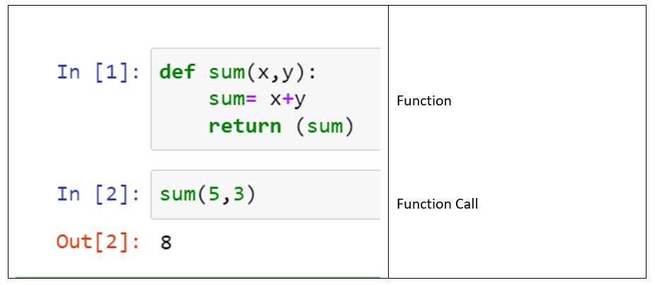

5. How many global scopes are there in a Python program? How many local scopes?

Global Scope- one

Local Scope – multiple

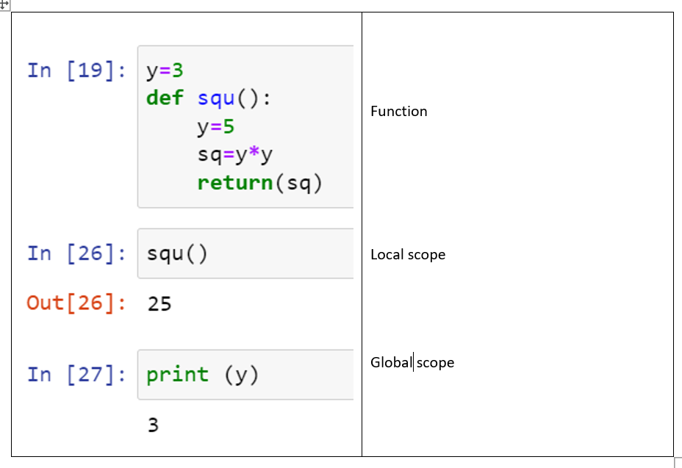

6. What happens to variables in a local scope when the function call returns?

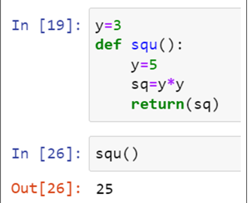

It will retain its value what is defined in function.

Ex Y retain value of 5

7. What is the concept of a return value? Is it possible to have a return value in an expression?

**Return** is statement used in function which give the result of function when it calls.

Yes Return value can be shown as expression

Ex 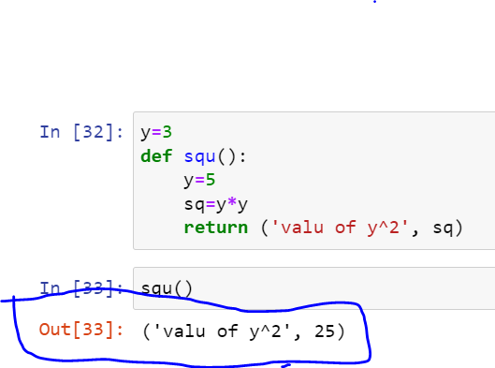

8. If a function does not have a return statement, what is the return value of a call to that function?

It will not show the result of function.

Ex 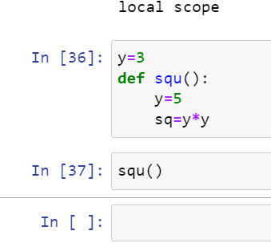

9. How do you make a function variable refer to the global variable?

By putting outside the function

Ex 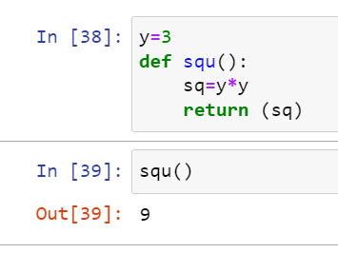

10. What is the data type of None?

Ex- It can not be used further for operation

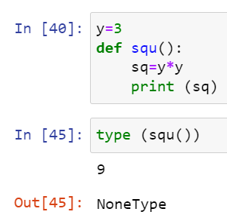

11. What does the sentence import areallyourpetsnamederic do?

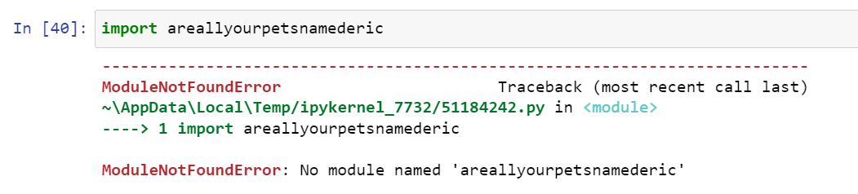

12. If you had a bacon() feature in a spam module, what would you call it after importing spam?

This function can be called with spam.bacon(). like below

import spam

spam.bacon()

13. What can you do to save a programme from crashing if it encounters an error?

**By using TRY statement**

14. What is the purpose of the try clause? What is the purpose of the except clause?

- Try clause used when we are not sure about the code and it might have exceptional error

For ex a/b, a=10, b=0 and over all code will stop run.

To avoid same , we put the code in TRY clause

Except clause used when executed when Try clause will have exception error.

And it can inform that there is exception error in the code.

Ex

